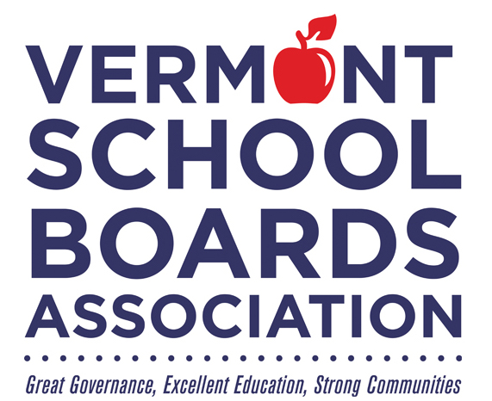

**School Board Appreciation Month**

**February 2025**

*Honoring*

**_______________________________________________**

*For commitment to public education and*

*continued service to Vermont's students.*